Project Planning Phase
Project Planning (Product Backlog, Sprint Planning, Stories, Story points)

Date | 13 February 2026
Team ID | LTVIP2026TMIDS34601
Project Name | TransLingua
Maximum Marks | 5 Marks

Product Backlog, Sprint Schedule, and Estimation (4 Marks)
Sprint | Functional Requirement (Epic) | User Story Number | User Story / Task | Story Points | Priority | Team Members
Sprint-1 | Setup | USN-1 | Set up project with Streamlit, google-generativeai, python-dotenv | 2 | High | Hritik Raj
Sprint-1 | Setup | USN-2 | Configure Gemini API securely using .env variables | 1 | High | Hritik Raj
Sprint-2 | Translation | USN-3 | Text input area (max 3000 chars) with char counter | 2 | Low | Sri Nandana Lahari
Sprint-1 | Translation | USN-4 | Source and target language dropdowns (25+ languages) | 2 | Medium | Sri Nandana Lahari
Sprint-1 | Translation | USN-5 | AI-powered translation via Gemini API | 3 | High | Mounika Vemala
Sprint-1 | Auto-Detect | USN-6 | Auto-detect source language using AI prompts | 3 | High | Mounika Vemala
Sprint-1 | Feedback | USN-7 | Multi-stage progress bar during translation | 2 | Medium | Sannidhiraju Sai Vinay
Sprint-1 | Error Handling | USN-8 | Error messages for empty text / same languages | 1 | Low | Mounika Vemala

Sprint | Functional Requirement (Epic) | User Story Number | User Story / Task | Story Points | Priority | Team Members
Sprint-2 | UI Design | USN-9 | Cyberpunk-themed UI with neon glow, animations | 5 | Medium0 | Hritik Raj
Sprint-2 | UI Design | USN-10 | Stats cards (25+ Languages, 99% Accuracy, etc.) | 2 | High | Hritik Raj
Sprint-2 | Controls | USN-11 | Copy translated text button | 1 | Low | Sri Nandana Lahari
Sprint-2 | Controls | USN-12 | Reset / clear all inputs button | 1 | Medium | Hritik Raj
Sprint-2 | Controls | USN-13 | Share translated text button | 1 | High | Mounika Vemala
Sprint-2 | Sidebar | USN-14 | Features and use cases sidebar panel | 2 | High | Sannidhiraju Sai Vinay
Sprint-2 | Results | USN-15 | Side-by-side original and translated display | 3 | Medium | Sannidhiraju Sai Vinay
Sprint-2 | Footer | USN-16 | Team info footer section | 1 | Low | Mounika Vemala

Project Tracker, Velocity & Burndown Chart: (4 Marks)
Sprint | Total Story Points | Duration | Sprint Start Date | Sprint End Date (Planned) | Story Points Completed (as on Planned End Date) | Sprint Release Date (Actual)
Sprint-1 | 16 | 4 Days | 02 Feb 2026 | 07 Feb 2026 | 16 | 07 Feb 2026
Sprint-2 | 16 | 5 Days | 08 Feb 2026 | 13 Feb 2026 | 16 | 13 Feb 2026

Velocity:
Imagine we have a 5-day sprint duration, and the velocity of the team is 16 (points per sprint). Let’s calculate the team’s average velocity (AV) per iteration unit (story points per day)

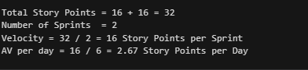
Burndown Chart:
A burn down chart is a graphical representation of work left to do versus time. It is often used in agile software development methodologies such as Scrum. However, burn down charts can be applied to any project containing measurable progress over time.

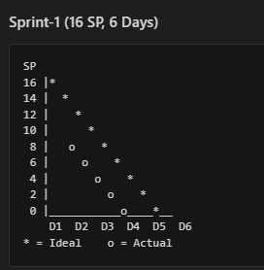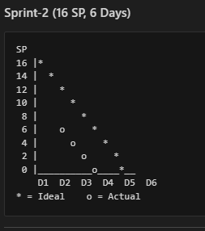

https://www.visual-paradigm.com/scrum/scrum-burndown-chart/
https://www.atlassian.com/agile/tutorials/burndown-charts

Reference:
https://www.atlassian.com/agile/project-management
https://www.atlassian.com/agile/tutorials/how-to-do-scrum-with-jira-software
https://www.atlassian.com/agile/tutorials/epics
https://www.atlassian.com/agile/tutorials/sprints
https://www.atlassian.com/agile/project-management/estimation
https://www.atlassian.com/agile/tutorials/burndown-charts

